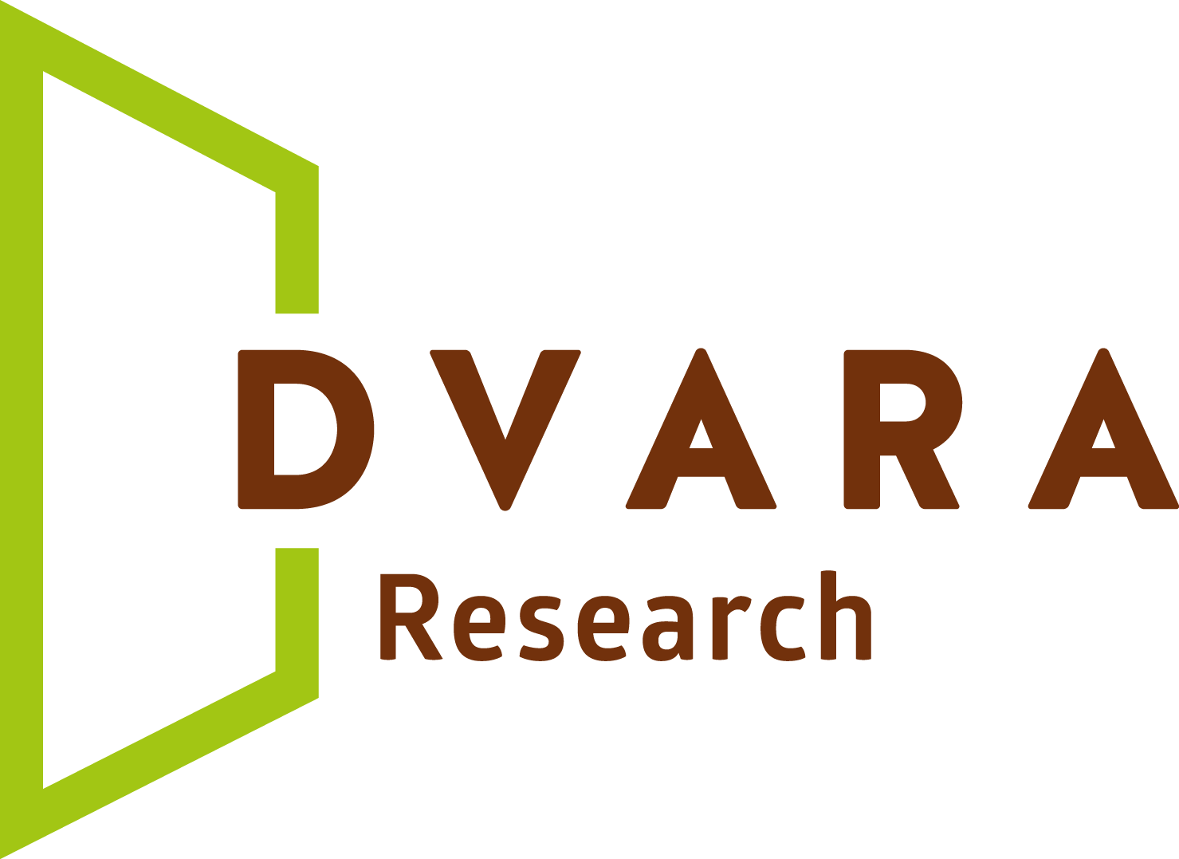
Voice of aggrieved customer| APPLICATION FORM

The Centre for Customer Protection at Dvara Research is announcing a call for proposals for the Voice of the Aggrieved Customer (VoAC) project. The Centre invites Consumer Groups, Self-Regulatory Organizations (SRO), industry associations, Financial Service Providers (FSPs) including digital FSPs, DFS agents and business correspondents, financial planners/advisors, investigative journalists, institutional and independent academicians, research institutions/think-tanks and scholars to submit proposals to document authentic experiences of customers, in the context of digital financial services and customer protection. Special consideration will be given to studies with a focus on poor and women customers in addition to other vulnerable groups.

Please fill in this form using Garamond 11 font, single spaced. Double-click on response boxes to mark your preference.

Title of Proposed Study Short but descriptive | State/s

- PROJECT OVERVIEW

Abstract (max. 200 words) Briefly state the objectives of your project and summarize the methodologies and output formats

Summary Timeline
Is the project ongoing? Has the documentation work or data collection begun? | Yes No
Expected Project Start Date (DD / MM / YYYY)
Expected Project End Date (DD / MM / YYYY)

Funding Requested
Total Project Budget  * include activities that have been implemented or will be funded by other donors |  | INR
Funding requested from Dvara Research  * if the project does not have other donors/funding sources, enter the total budget proposed |  | INR

PROJECT TEAM

In this section applicants will need to showcase their prior experience in documenting customer voice in the field of financial services. Higher scores will be given to applications with team members who are academically and experientially oriented in disciplines such as economics, statistics, sociology, anthropology, journalism and psychology. Applicants must demonstrate experience in a variety of qualitative field research that has resulted in high impact lived experience documentation for poor and women customers.

1.1a Primary Team Members
Full Name, Title and Designation | 1.  2.  3.
Relevant Experience | Does any member of your team have prior experience in documenting VoAC for poor and women customers?  Yes No  If yes, please provide a reference to one publication/output to support your answer.

1.2a Implementation and/or Practitioner Partner/s (if applicable)

If the primary team is expecting to partner with any third parties to implement the proposed project. These third parties could be financial service providers, government agencies, civil society organizations or survey companies and so on.

Name of the Organization
Organization’s Website

Lead Contact Person
First and Last Name and Job Title

Contact Email

Organization Website

- PROJECT NARRATIVE

The recommended length of the project narrative is not more than 3 pages (single-spaced, Garamond, 11-point font)
  - Context: Customer segment/s and grievance/s being documented

  - Relevance: to consumer protection and financial inclusion in the digital finance domain and potential for policymaker engagement.

  - Project Specifics: location, team and partner organization (if applicable) details

  - Project Design: implementation and timeline

  - Data collection and Outputs
  - Potential risks
  - Plans for results dissemination and output formats

PROJECT MILESTONES

Please list each key milestone for the project (e.g. finalizing research design, research instrument, data collection, final output in chosen output format, final study report, etc.). Normally we would expect each project to list 4-5 milestones. Add lines as needed.

# | Milestone | Target  Start Date | Target  End Date
1.
2.
3.
4.

- FINANCIAL QUALIFICATIONS

1. 2 years audited Financial Statements (use Annex I to attach JPEG/Screenshots)
2. Details of other funds from organizations/donors funding project activities relevant to this Proposal (if applicable, attach as PDF)

- SIGNED LETTER OF SUPPORT FROM PRACTITIONER ORGANIZATION/IMPLEMENTATION ORGANIZATION (IF APPLICABLE)

- ATTACHMENT: PROJECT BUDGET
PROPOSAL CHECKLIST
Project Application Form
Rename: CP_Proposal_[ResearcherLastName]_[OrgName]_2022.docx
Save the proposal (Sections 1 to 7, including this checklist) as a single Microsoft Word file.
- Project Overview
- Project Team
- Project Narrative

Project Milestones

Financial Qualifications (Annexure I)

Signed Letter of Support from Practitioner Organization (if applicable) (Annexure II)

Filled-in Proposal Checklist

Attachments

Project Budget

Rename: VoAC Project_Budget_[ResearcherLastName]_[OrgName]2022.xlsx

Submission deadline is 30th April, 2022.

Please email your submission to Anushree Nekkanti, Program Manager - Center for Customer Protection, Dvara Research, email: ccp@dvara.com . The subject line of your email should read:
“VoAC Proposal 2022 [ResearcherLastName] [OrgName]”

Annexure I

2 years of Audited Financial Statements – high resolution JPEGS can be pasted into this section of the word document. Originals will need to be submitted if the application is selected for the VoAC Project

Annexure II

JPEG/Screenshot of signed letter of support from Practitioner Organization/Implementation Organization can be pasted into this section of the word document. Originals will need to be submitted if the application is selected for the VoAC Project

Entries in this section need to be reflected in the Budget as well. If funding from sources, other than Dvara Research, have been/will be used please tick the “Partial Funding” option in the budget and substantiate with documentation as a PDF attachment to this application.
Specify why you have chosen this grievance/s and why you think it is important to provide a platform for this/these Voices to be heard? How prevalent is the grievance/s (please provide data where available) and what is the anticipated impact of bringing these stories into the limelight? Is the grievance geography specific? Is it a challenge faced predominantly by poor and women customers?
Provide a detailed description of your project design including your sampling frame, and the thought process used to select the aggrieved customers. Project activities need to be detailed in a table along with the timeline. Data collection procedures, qualitative research tools used and roll-out plan to collect and document aggrieved customer voices need to be highlighted. Specify one or more qualitative methodologies, your project will use to collect data for the VoAC project. Please also describe the roles and responsibilities of the members of the project team
Specify target outcomes, data collection and story documentation plans clearly. Also specify the details of the sample under study – geography and other socio-economical factors considered while choosing the sample. (Refer RFP for further details for guidance on expected Outputs and Outcomes)
Briefly present the potential biases and risks to the study/case. How do you expect to limit such risks or correct for them?
Specify the format/s in which the VoAC story/ies will be harvested. Formats can include but are not limited to the following - qualitative and ethnographic surveys, one-on-one in-depth interviews, focus group discussions, video documentaries and/or field diaries. Also detail any plans to complement DR’s efforts in dissemination.

